LETTERKENNY INSTITUTE OF TECHNOLOGY

ASSIGNMENT COVER SHEET

**Lecturer’s Name**: Maria Griffin

**Assessment Title:**  Lab 1

**Work to be submitted to:**  Maria Griffin

**Date for submission of work:**  22-10-2021

**Place and time for submitting work:**  Blackboard

To be completed by the Student

**Student’s Name:**  Snehal Khairnar

**Class:**  MSc in DevOps

**Subject/Module:**  DevOps Software Engineering (2021/22)

**Word Count (where applicable):**  N/A

**I confirm that the work submitted has been produced solely through my own efforts.**

**Student’s signature: Date:**  << 21/10/2021>>

|  |
| --- |
| **Notes**  **Penalties:** The total marks available for an assessment is reduced by 15% for work submitted up to one week late. The total marks available are reduced by 30% for work up to two weeks late. Assessment work received more than two weeks late will receive a mark of zero. [Incidents of alleged plagiarism and cheating are dealt with in accordance with the Institute’s Assessment Regulations.]  **Plagiarism:** Presenting the ideas etc. of someone else without proper acknowledgement (see section L1 paragraph 8).  **Cheating:** The use of unauthorised material in a test, exam etc., unauthorised access to test matter, unauthorised collusion, dishonest behaviour in respect of assessments, and deliberate plagiarism (see section L1 paragraph 8).  **Continuous Assessment:** For students repeating an examination, marks awarded for continuous assessment, shall normally be carried forward from the original examination to the repeat examination. |
|  |

# Aim

Continuous integration is a software development method that allows code from multiple contributors to be automatically integrated into a single software project (REHKOPF, 2021). The aim for this lab is to implement the DevOps pipeline by code through Java, built through Maven, and continuous integration tool GitHub to perform automation testing through GitHub action.

# Method

* Install Java SE, Java SE installed successfully.
* Install Apache Maven, maven installed successfully
* To execute Java code, eclipse IDE for java developer installed
* Open eclipse, create new Maven project in eclipse, named Maven_test
* Under src/main/java, create add.java file under package mvn_pkg to check the addition of the two numbers and print the result

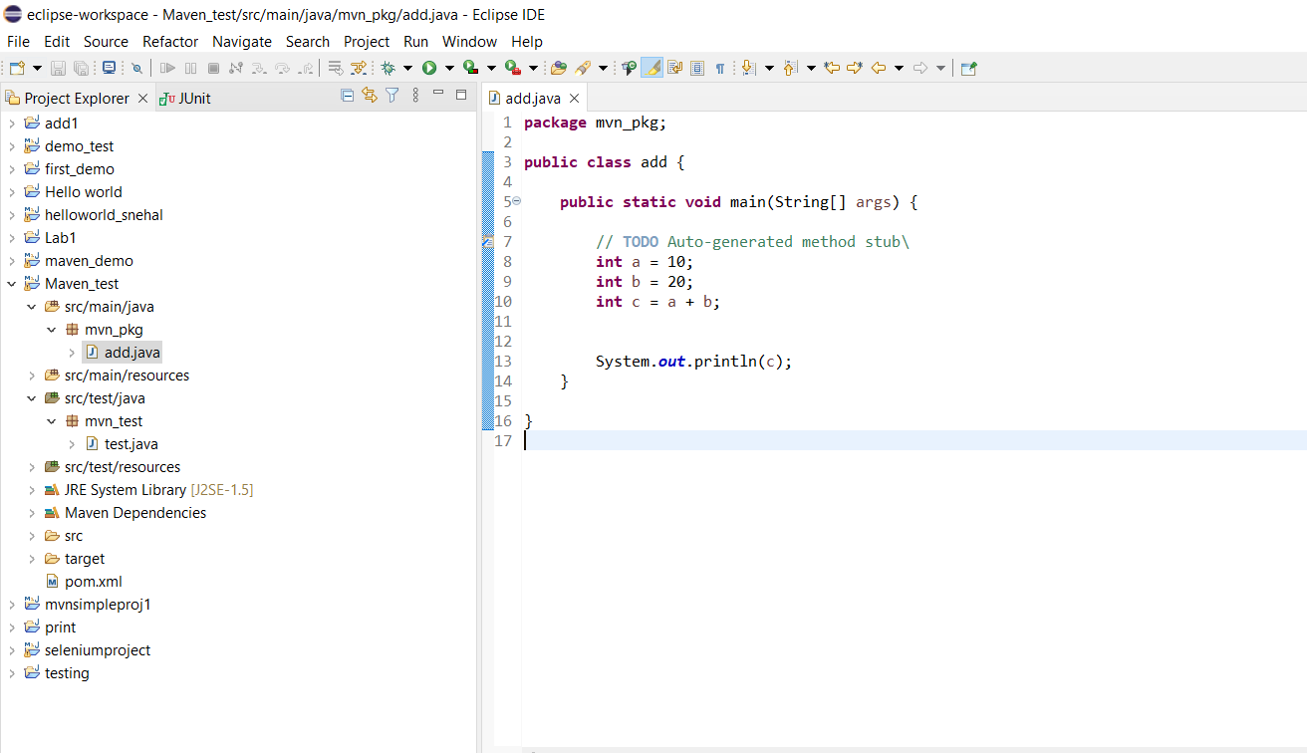

* Under src/test/java, create a test file named as Test.java to verify the addition

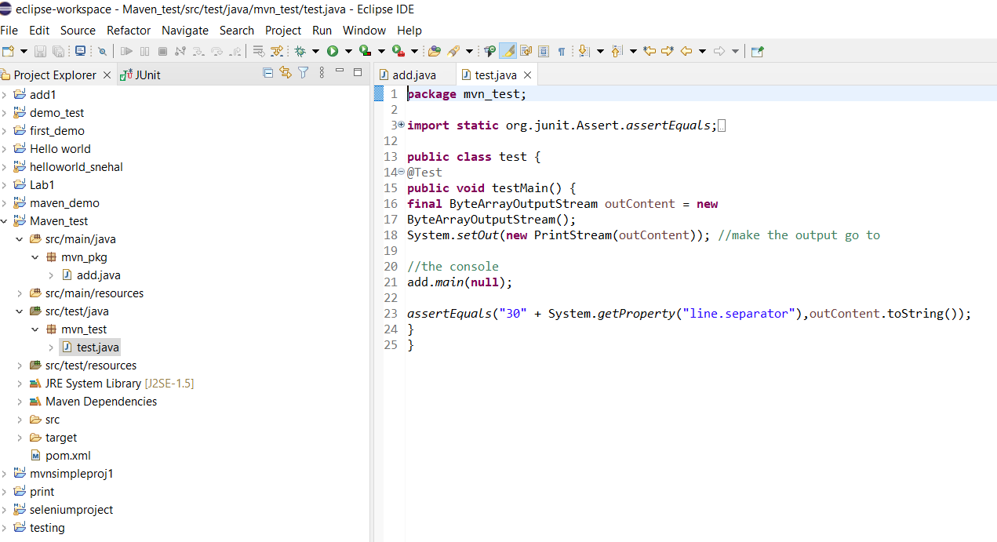

* In the maven project, the pom.xml file is present where JUnit dependencies are added,

After adding the pom.xml file looks like

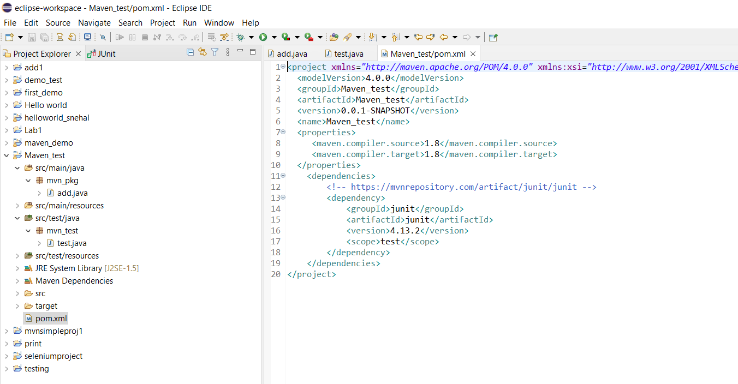

* Code pushed into git hub repository

<https://github.com/Snehalkhairnar9/maven_project>

* Go to git hub actions, create new workflow click on Java with maven, commit maven.yml in Github, automatically run the test

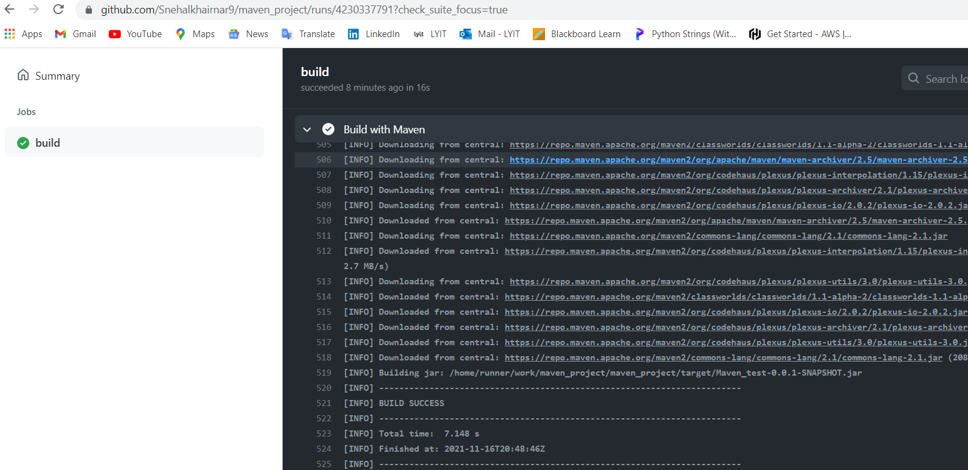

# Results

1. Maven project created in eclipse, added Java file for the addition of two numbers successfully.

2. Created unit test for testing addition of numbers in the test file and added Junit dependencies to execute the Junit test.

3. Junit test passed successfully, after that code pushed into GitHub Repository

4. Automated the test with the help of GitHub actions.

5. Build with Maven was successful.

# Conclusion

Remaining, will add

.

# References & Bibliography

1. Narebski., J., 2016. *Mastering Git*. Packt Publishing.
2. REHKOPF, M., 2021. *What is Continuous Integration | Atlassian*. [online] Atlassian. Available at: <https://www.atlassian.com/continuous-delivery/continuous-integration> [Accessed 19 October 2021].
3. Pensalwar, V., 2021. *Jenkins Case Study*. [online] Linkedin.com. Available at: <https://www.linkedin.com/pulse/jenkins-case-study-venkatesh-pensalwar/> [Accessed 19 October 2021].
4. Edureka. 2021. *What is Continuous Integration? | Continuous Integration using Jenkins | Edureka*. [online] Available at: <https://www.edureka.co/blog/continuous-integration/> [Accessed 17 October 2021].
5. Softwaretestingmaterial.com. 2021. *Git*. [online] Available at: <https://www.softwaretestingmaterial.com/git-tutorial/> [Accessed 21 October 2021].